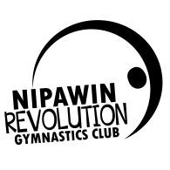
Why Gymnastics? Gymnastics is considered a foundational sport by the international Olympic Committee. By this definition Gymnastics is a sport that helps improve future performance of an athlete in all other sports. This means that kids with a history in gymnastics make better all-round athletes.
Now Nipawin has a facility devoted to just that! The Nipawin Centre for Gymnastics and Athletic development ltd. (NCGAD) is just what the name says, it is a facility dedicated to helping better athletes of all ages and disciplines, both competitive and recreational levels.
The NCGAD would like to partner with local businesses to increase visibility and support the NCGAD and Nipawin Revolution Gymnastics Club inc. (NRG inc.)
Presently there are LARGE empty walls and over 140 participants registered for weekly classes plus well attended drop ins every week. We are planning adult classes, senior classes and summer camps as well as fun meets and competitions in the near future. Your business name could be seen by hundreds of people every week! Be one of the first to get your name on the wall and support gymnastics in Nipawin.
Option 1.)
Provide a Banner to be posted on our wall. Annual fee based on sizes and location. Fees are annual 3 year terms available:
- 4x8ft Banner posted on gym facility interior: $150-$300
- On Vertical Pillars $75
- Front door and entrance $100

Option 2.)
We do all our registration online at nipawingymnastics.com. Hundreds of people view this site every session! Get your logo with a Link your website or facebook page on the NRG inc. web page (Great for restaurants and spas as we are planning a monthly date night)
- On the Home page with link to you site/Facebook Page: $100
- On the Sponsors page with link $50

Option 3.)
Donate equipment or mats to NRG inc. We will post your logo on our website with a link and on the equipment donated and get free banner for 1 year by any stationary equipment. (Contact for prices etc.)

To arrange posting please call or email Doug Gudnason Cell: 306-769-7224 (douggudnason@gmail.com). All fees go toward facility maintenance, improvements and equipment purchases.

We look forward to working with you and thank you in advance for your support,

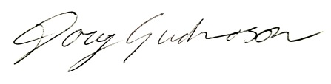
Doug Gudnason
Director NCGAD and Rec. Director and Men’s Coach NRG inc.

